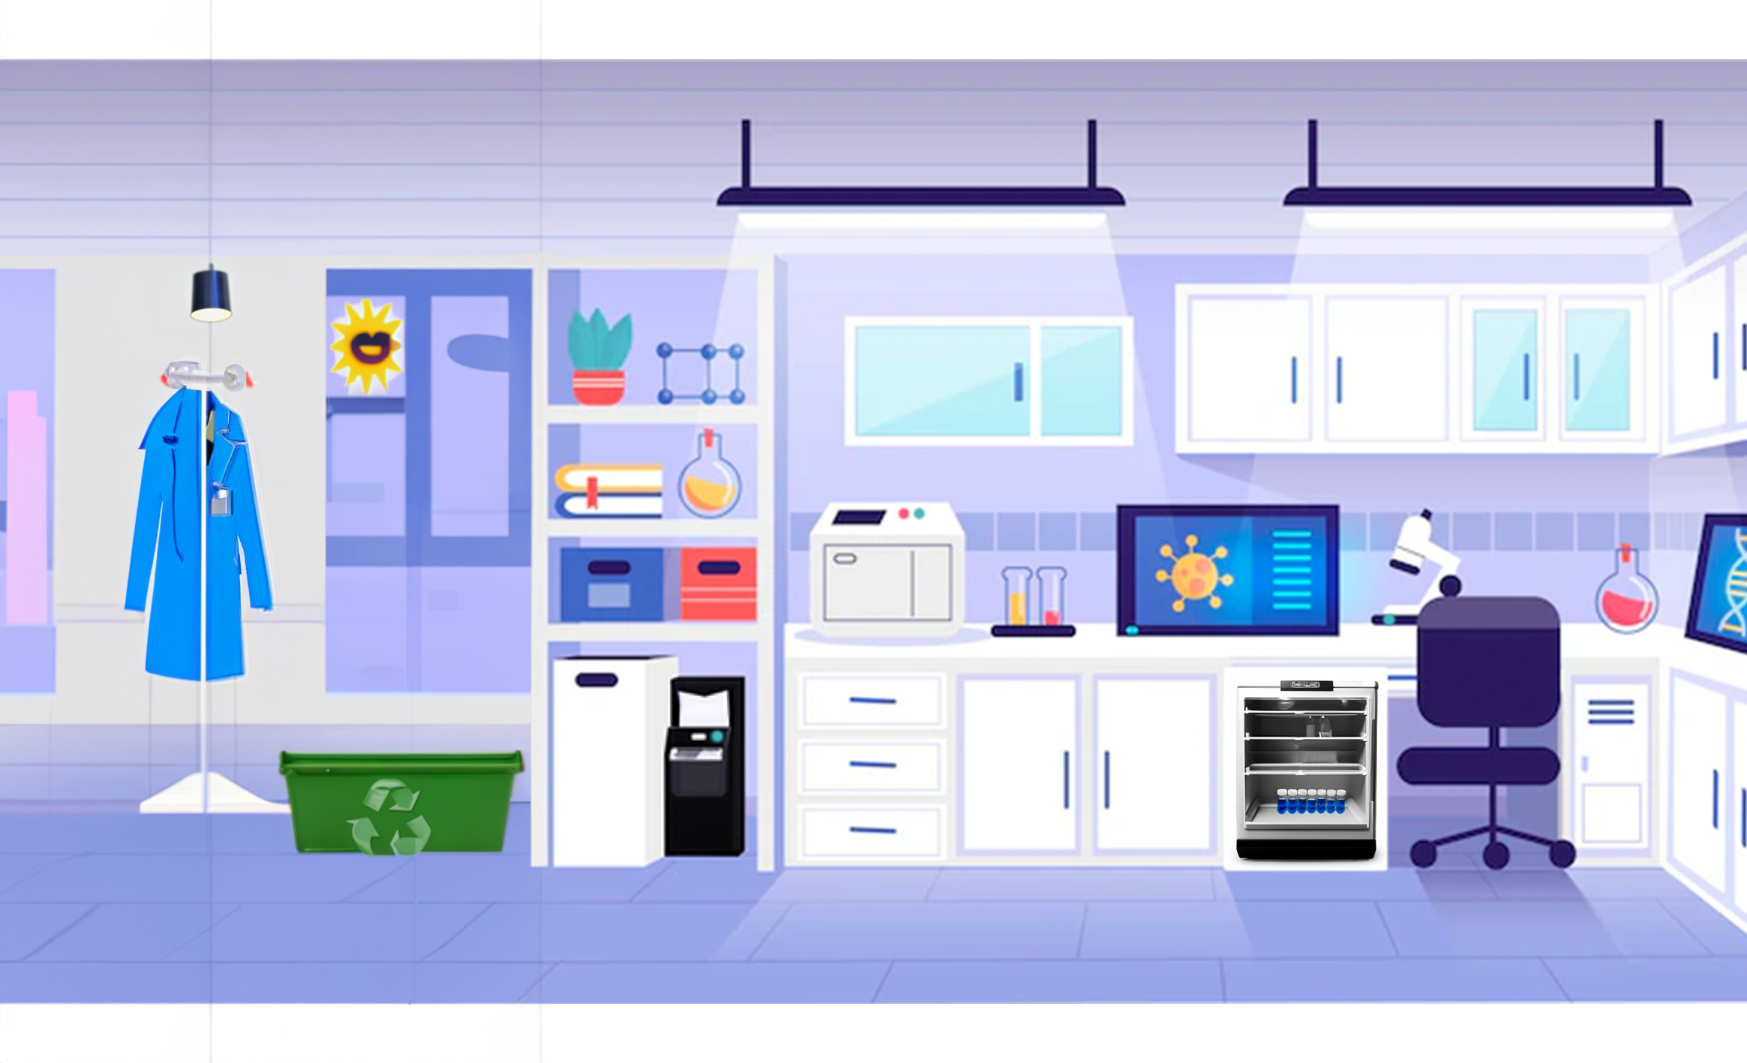

10 C

0.00

|  |  |  |
| --- | --- | --- |
| The two ceiling lamps in the lab are CFL’s(Compact Fluorescent Lamps). The voltage into one of these lamps is 230 V and the current is 0.17A. | The incandescent light bulb above the reusable lab coat is connected to a mains supply of 230V and the current is 0.65A. | The paper shredder typically uses 200 watts of power per hour |
| The mini fridge running at 10 degrees Celsius is connected to a 230 mains voltage and the current is 1A | The microscope is battery powered. The voltage supplied by the battery is 110V. The electrical power is 220W. | The centrifuge is on but is not in use. It consumes 1050J per second.  It is an energy vampire, when on standby it uses 800 W. |
| The virus incubator often is filled with samples, so it is always kept on. | The IPad with the DNA screensaver consumes 200J per second when on standby. | The vials in the fridge are made from plastic. |
| The lab coat is reusable. Visitors to the lab use a one-use plastic lab coat. | The sun is shining outside, but there are three lights on in the lab. | The recycling bin is for paper only |

|  |  |  |
| --- | --- | --- |
| The two ceiling lamps in the lab are CFL’s(Compact Fluorescent Lamps). The voltage into one of these lamps is 230 V and the current is 0.17A. | The incandescent light bulb above the reusable lab coat is connected to a mains supply of 230V and the current is 0.65A. | The paper shredder typically uses 200 watts of power per hour |
| The mini fridge running at 10 degrees Celsius is connected to a 230 mains voltage and the current is 1A | The microscope is battery powered. The voltage supplied by the battery is 110V. The electrical power is 220W. | The centrifuge is on but is not in use. It consumes 1050J per second.  It is an energy vampire, when on standby it uses 800 W. |
| The virus incubator often is filled with samples, so it is always kept on. | The IPad with the DNA screensaver consumes 200J per second when on standby. | The vials in the fridge are made from plastic. |
| The lab coat is reusable. Visitors to the lab use a one-use plastic lab coat. | The sun is shining outside, but there are three lights on in the lab. | The recycling bin is for paper only |

|  |  |  |
| --- | --- | --- |
| The two ceiling lamps in the lab are CFL’s(Compact Fluorescent Lamps). The voltage into one of these lamps is 230 V and the current is 0.17A. | The incandescent light bulb above the reusable lab coat is connected to a mains supply of 230V and the current is 0.65A. | The paper shredder typically uses 200 watts of power per hour |
| The mini fridge running at 10 degrees Celsius is connected to a 230 mains voltage and the current is 1A | The microscope is battery powered. The voltage supplied by the battery is 110V. The electrical power is 220W. | The centrifuge is on but is not in use. It consumes 1050J per second.  It is an energy vampire, when on standby it uses 800 W. |
| The virus incubator often is filled with samples, so it is always kept on. | The IPad with the DNA screensaver consumes 200J per second when on standby. | The vials in the fridge are made from plastic. |
| The lab coat is reusable. Visitors to the lab use a one-use plastic lab coat. | The sun is shining outside, but there are three lights on in the lab. | The recycling bin is for paper only |

|  |  |  |
| --- | --- | --- |
| The two ceiling lamps in the lab are CFL’s(Compact Fluorescent Lamps). The voltage into one of these lamps is 230 V and the current is 0.17A. | The incandescent light bulb above the reusable lab coat is connected to a mains supply of 230V and the current is 0.65A. | The paper shredder typically uses 200 watts of power per hour |
| The mini fridge running at 10 degrees Celsius is connected to a 230 mains voltage and the current is 1A | The microscope is battery powered. The voltage supplied by the battery is 110V. The electrical power is 220W. | The centrifuge is on but is not in use. It consumes 1050J per second.  It is an energy vampire, when on standby it uses 800 W. |
| The virus incubator often is filled with samples, so it is always kept on. | The IPad with the DNA screensaver consumes 200J per second when on standby. | The vials in the fridge are made from plastic. |
| The lab coat is reusable. Visitors to the lab use a one-use plastic lab coat. | The sun is shining outside, but there are three lights on in the lab. | The recycling bin is for paper only |

|  |  |  |
| --- | --- | --- |
| The two ceiling lamps in the lab are CFL’s(Compact Fluorescent Lamps). The voltage into one of these lamps is 230 V and the current is 0.17A. | The incandescent light bulb above the reusable lab coat is connected to a mains supply of 230V and the current is 0.65A. | The paper shredder typically uses 200 watts of power per hour |
| The mini fridge running at 10 degrees Celsius is connected to a 230 mains voltage and the current is 1A | The microscope is battery powered. The voltage supplied by the battery is 110V. The electrical power is 220W. | The centrifuge is on but is not in use. It consumes 1050J per second.  It is an energy vampire, when on standby it uses 800 W. |
| The virus incubator often is filled with samples, so it is always kept on. | The IPad with the DNA screensaver consumes 200J per second when on standby. | The vials in the fridge are made from plastic. |
| The lab coat is reusable. Visitors to the lab use a one-use plastic lab coat. | The sun is shining outside, but there are three lights on in the lab. | The recycling bin is for paper only |

|  |  |  |
| --- | --- | --- |
| The two ceiling lamps in the lab are CFL’s(Compact Fluorescent Lamps). The voltage into one of these lamps is 230 V and the current is 0.17A. | The incandescent light bulb above the reusable lab coat is connected to a mains supply of 230V and the current is 0.65A. | The paper shredder typically uses 200 watts of power per hour |
| The mini fridge running at 10 degrees Celsius is connected to a 230 mains voltage and the current is 1A | The microscope is battery powered. The voltage supplied by the battery is 110V. The electrical power is 220W. | The centrifuge is on but is not in use. It consumes 1050J per second.  It is an energy vampire, when on standby it uses 800 W. |
| The virus incubator often is filled with samples, so it is always kept on. | The IPad with the DNA screensaver consumes 200J per second when on standby. | The vials in the fridge are made from plastic. |
| The lab coat is reusable. Visitors to the lab use a one-use plastic lab coat. | The sun is shining outside, but there are three lights on in the lab. | The recycling bin is for paper only |

**Research Questions (you may use a device if you need)**

What is an energy vampire?

What is a centrifuge?

What is an incubator?

What is a virus? Can you give an example of a virus?

Can plastic lab aprons be recycled?

How are chemical vials/ bottles that held chemicals recycled in labs?

**Brainstorm: This, not that**

Sustainability is becoming a key practice in all aspects of our lives and its vital to translate this into our workplaces. Due to the nature of the highly regulated work in laboratories it may seem impossible at first to tackle the overwhelming task of making the lab more sustainable. However, implementing small changes can have a big impact overall making the lab ‘Greener’ in the process.

**Q. What changes can be made to the above lab to become Greener?**

**Match up the practices below that can accomplish the goal of a Green Lab**

|  |  |  |
| --- | --- | --- |
| Plug in timers |  | Used to identify devices that are large energy consumers |
| An Energy meter |  | Report immediately to a relevant person |
| Donate |  | Consider what is the most efficient |
| When purchasing equipment/devices |  | Can be used for water baths/incubators to keep them running at the correct temperature at essential times only |
| Leaks |  | Use a ‘first in first out’ policy |
| Expiry dates |  | Unwanted or unused supplies/equipment/furniture |

**Calculators at the ready!**

Calculate the power used by both ceiling lamps. Don’t forget units!

For every 100J of electrical energy supplied to a CFL, 10J transforms into heat energy. In comparison, for every 100J supplied to an incandescent lamp, 30J transform into heat energy. Which lamp is more efficient: The CFL or the incandescent lamp? Show your workings.

In the space below draw Sankey diagrams for both lamps.

Name a type of light that is more efficient than both of these options. Why is it more efficient?

Calculate the power used by the fridge at 10 degrees.

If the fridge temperature was raised slightly to 15 degrees Celsius, the current used would reduce to 0.8A. How much power would the fridge use at this temperature?

A group of science students are performing an experiment in the lab that requires the solutions they are using to be at approximately 80 degrees Celsius. The young scientists could use a water bath or they could use water from a kettle.

The solutions need to be kept at 80 degrees for 1 hour. The hot water bath takes one hour to heat up. The kettle would need to be boiled four times to maintain the water temperature throughout the experiment.

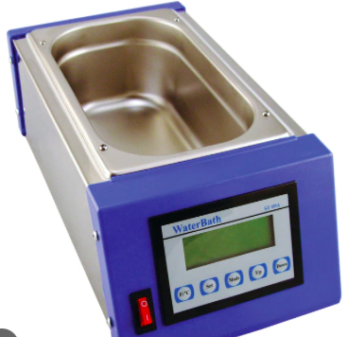

|  |  |
| --- | --- |
| Hot Water Bath power consumption | Kettle power consumption |
| 28J are consumed every second while heating up  6J are consumed every second to maintain the temperature | To boil the kettle, 22J are consumed every second, the total time to boil the kettle is 2 minutes |

Calculations:

Which method uses the least amount of energy?__________________________

To reduce heat loss from a water bath a lid can be placed on top.

What type of material should this lid be made from?

__________________________________