NUA NA MARA, MARINE INNOVATION DEVELOPMENT CENTRE AND BIORBIC, BIOECONOMY SFI RESEARCH CENTRE SIGN MEMORANDUM OF UNDERSTANDING

BiOrbic, Bioeconomy SFI Research Centre and Nua na Mara, Marine Innovation Development Centre have signed an MOU to collaborate and lead the way for the development of Ireland’s blue bioeconomy. The objective for this MOU is for both parties to engage together to strengthen, promote and develop co-operation in research, development and innovation, commercialisation, education and training in the thematic areas of marine bioeconomy with a special focus on SME and start-up companies.

The new collaboration was formally announced today as part of Bioeconomy Ireland Week 2022. This week is an annual week-long event where an all-island community of businesses, research centres, business clusters, communities and government agencies gather to showcase leading bioeconomy and climate action.

Nua na Mara is an enterprise founded by Údarás na Gealtacha and Enterprise Ireland, and is an entity dedicated to supporting the development of marine start-ups, early-stage companies, and existing businesses. Nua na Mara will leverage their connections within the marine industry here in Ireland and further afield to help marine start-ups to bridge the gap in linking innovation, application, concepts, and commercialisation. Nua na Mara gives access to the word class research, testing and enterprise development facilities for the marine sector provided by GMIT and NUI Galway. Nua na Mara aims to support and nurture SME’s and start-ups with supports such as training and development, access to funding and grant aid, access to facilities, and acts as a gateway to key stakeholders in the marine Industry

BiOrbic is Ireland’s National Bioeconomy Research Centre, supported by Science Foundation Ireland and hosted by University College Dublin and including current partner institutions Trinity College Dublin, University of Limerick, National University of Ireland Galway, Teagasc and Munster Technological University. The Centre is focused on developing a sustainable circular Irish bioeconomy.

Derek O’Brien, Executive Director of BiOrbic, says “We are delighted to be partnering with Nua na Mara to further advance the development of the blue bioeconomy. Future innovations and products in the area will emerge from marine start-ups, early-stage companies, and existing businesses. We are hugely impressed with the supports Nua na Mara provide to these companies. A focus for us in BiOrbic is to work with leading organisations like Nua na Mara to connect and strengthen the bioeconomy innovation ecosystem.

Cliodhna Ní Ghriofa, Business Development Manager of Nua na Mara comments “ We are thrilled to sign an MOU with BiOrbic, a formal commitment to strengthen the collaboration for the Blue Bioeconomy. We envisage this MOU to be the start of a cohesive and collaborative relationship that will leverage the knowledge and experience of both organisations for the wider benefit of start ups and early stage companies in the blue bioeconomy. Nua na Mara have always admired the commitment, dedication and empowerment that BiOrbic provides to the sector and we are delighted to bring the Marine Gaeltacht to the forefront with BiOrbic.
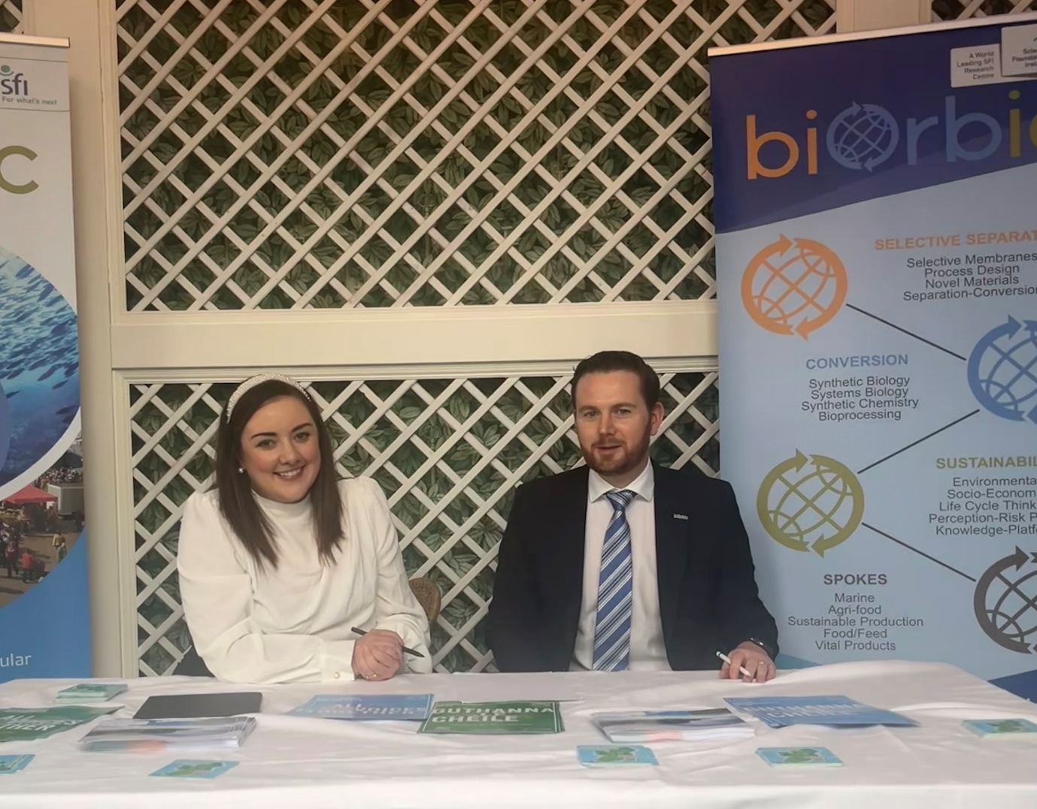
Nua na Mara Business Development Manager, Cliodhna ní Ghriofa with Derek O Brien, CEO BiOrbic signing the MOU at Bioeconomy Summit 2022.

